Decision Tree Classification of High Diabetes Prevalence in African Countries Using IDF Atlas Data

NAME: JOHN AWOTWE ESHUN
15TH MARCH, 2026

Abstract
Diabetes is a growing public health challenge in Africa, where many countries continue to face high levels of undiagnosed cases, diabetes-related deaths, and limited health expenditure. Despite this, research applying interpretable machine learning models to country-level diabetes indicators in Africa remains limited, as most existing studies focus on patient-level diagnosis within single-country settings. This study aimed to classify African countries into high- and low-diabetes-prevalence groups using selected national-level indicators from the International Diabetes Federation (IDF) Atlas. A quantitative cross-sectional design was adopted using secondary data for the 2024 reference year. After data cleaning, the final analytical sample consisted of 48 African countries. The outcome variable was prevalence status, classified as high or low using the sample median age-standardised prevalence of 5.40%. Predictor variables included undiagnosed diabetes, deaths attributable to diabetes, the proportion of diabetes-related deaths, health expenditure, and adult population. Data were analysed using descriptive statistics, a Classification and Regression Tree (CART) model, and logistic regression. The CART model achieved 92.86% accuracy, while logistic regression achieved 100.00% on the test sample. The most important predictor was the proportion of diabetes-related deaths. The study concludes that interpretable machine learning can support diabetes surveillance and policy planning in Africa.

Keywords: diabetes prevalence, Africa, CART, logistic regression, interpretable machine learning, IDF Atlas

TABLE OF CONTENTS

Abstract 1
1 INTRODUCTION 6
1.1 PROBLEM STATEMENT 6
1.2 RESEARCH QUESTIONS 7
1.3 RESEARCH OBJECTIVES 7
2 LITERATURE REVIEW 8
2.1 EMPIRICAL REVIEW 8
2.2 CONCEPTUAL FRAMEWORK 10
3 METHODOLOGY 11
3.1 RESEARCH DESIGN 11
3.2 DATA SOURCE AND STUDY SAMPLE 11
3.3 VARIABLES 11
3.4 DATA ANALYSIS 12
4 RESULTS 12
4.1 SAMPLE SIZE AND CLASS DISTRIBUTION 12
4.2 DISTRIBUTION OF DIABETES PREVALENCE ACROSS AFRICAN COUNTRIES 13
4.2.1 DESCRIPTIVE STATISTICS 13
4.3 CART CLASSIFICATION OF HIGH-PREVALENCE AND LOW-PREVALENCE COUNTRIES 14
4.3.1 CART MODEL PERFORMANCE 14
4.3.2 INTERPRETATION OF THE PRUNED CART MODEL 15
4.3.3 VARIABLE IMPORTANCE 15
4.4 COMPARISON OF CART AND LOGISTIC REGRESSION MODELS 16
4.4.1 LOGISTIC REGRESSION PERFORMANCE 16
4.4.2 MODEL COMPARISON 16
5 DISCUSSION 17
5.1 DISTRIBUTION OF DIABETES PREVALENCE ACROSS AFRICAN COUNTRIES 17
5.2 CART CLASSIFICATION OF HIGH-PREVALENCE AND LOW-PREVALENCE COUNTRIES 17
5.3 COMPARISON OF CART AND LOGISTIC REGRESSION MODELS 18
5.4 STUDY IMPLICATIONS 19
5.5 LIMITATIONS OF THE STUDY 19
6 CONCLUSION 19
6.1 RECOMMENDATIONS 20

LIST OF TABLES

Table 1.Distribution of Countries by Diabetes Prevalence Classification 12
Table 2.Descriptive Statistics of Diabetes-Related Indicators Across African Countries (N = 48) 13
Table 3.Variable Importance in the Pruned CART Model 16
Table 4.Performance Comparison of CART and Logistic Regression Models 16

LIST OF FIGURES
Figure 1. Conceptual framework for the classification of diabetes prevalence in African countries 11
Figure 2. Distribution of age-standardised diabetes prevalence across African countries 15
Figure 3. Pruned CART decision tree for classifying high and low diabetes prevalence 16

CHAPTER ONE

INTRODUCTION
Over 580 million persons worldwide suffer from diabetes which s one of the most fastest growing non-communicable diseases globally. Urbanisation, population ageing, changes in lifestyle, and a lack of preventive health interventions are all contributing factors to the rising prevalence of diabetes. It is projected that by 2050, diabetes cases are expected to rise across Africa at one of the greatest relative rates, posing significant challenges to the continent's already limited health systems (Genitsaridi et al., 2025).
Despite this growing public health concern, a significant percentage of diabetes patients in Africa go undetected. Delays in diagnosis, poor disease treatment, and higher mortality are caused by high rates of undiagnosed diabetes, restricted access to screening programs, and insufficient health spending. These structural flaws emphasize the necessity of data-driven strategies that can enable focused policy responses and assist in identifying high-risk national settings (Ogurtsova et al., 2022; Genitsaridi et al., 2025).
In diabetes research, machine learning approaches have been used more and more, especially to predict individual-level diagnosis utilising clinical and patient data. Strong predictive performance has frequently been shown by algorithms like ensemble methods, support vector machines, and neural networks. However, many of these models only produce forecasts with great accuracy for policymakers and health professionals frequently find it challenging to understand the logic behind them. Furthermore, the majority of current research concentrates on patient-level information in single-country contexts, paying little attention to surveillance data at the national level throughout Africa. These structural weaknesses highlight the need for data-driven approaches that can help identify high-risk national contexts and support targeted policy responses (Ogurtsova et al., 2022; Genitsaridi et al., 2025).
There is therefore a notable gap in the literature regarding the application of interpretable machine learning models to national diabetes indicators in African countries. Few studies integrate system-level variables such as diabetes prevalence, undiagnosed rates, mortality and health expenditure into predictive frameworks capable of producing clear and policy-relevant decision rules (Sun et al., 2022; Ogurtsova et al., 2022).
This study applies an interpretable decision tree model to classify African countries into high-diabetes prevalence and low-diabetes-prevalence groups using selected national-level diabetes indicators from the IDF Atlas.

PROBLEM STATEMENT
Although diabetes prevalence in Africa is increasing rapidly, many countries still lack practical and interpretable analytical tools to support targeted public health decision-making. Existing research has focused largely on patient-level clinical diagnosis using machine learning techniques. Even though many of these models achieve high predictive accuracy, they often operate as complex “black-box” systems that are difficult for policymakers to interpret and apply at the national planning level (Genitsaridi et al., 2025; Ismail et al., 2022; Ganguly & Singh, 2023).
Furthermore, limited research has examined country-level diabetes indicators such as prevalence, undiagnosed rates, mortality, and health expenditure within an integrated predictive framework across multiple African countries. As a result, health ministries and policymakers may lack structured evidence on the key system-level factors associated with high diabetes prevalence across countries (Sun et al., 2022; Ogurtsova et al., 2022).
Resource allocation and prevention tactics may continue to be ineffective or misguided in the absence of interpretable models that convert surveillance data into practical decision rules. There is therefore a need for an explainable machine learning approach that can classify African countries into high- and low-prevalence groups and identify the most influential predictors in a transparent and policy-relevant manner (Ganguly & Singh, 2023).

RESEARCH QUESTIONS
- What is the distribution of diabetes prevalence across African countries according to IDF Atlas data?
- Which national-level diabetes indicators best distinguish high-prevalence countries from low-prevalence countries?
- How accurately can a decision tree model classify African countries into high-prevalence and low-prevalence groups?

RESEARCH OBJECTIVES
- To examine the distribution of diabetes-related indicators across African countries using exploratory data analysis.
- To construct a binary classification variable representing high and low diabetes prevalence.
- To develop a CART decision tree model using selected national-level diabetes indicators.
- To evaluate the performance of the CART model using a confusion matrix, accuracy, precision, recall, and F1-score.
- To compare the performance of the CART decision tree model with logistic regression as a benchmark classifier.

CHAPTER TWO

LITERATURE REVIEW

EMPIRICAL REVIEW
In diabetes research, machine learning has been used more and more to improve clinical decision-making and predictive accuracy. Much of the empirical literature has focused on the use of supervised learning algorithms for individual-level diabetes diagnosis. Ismail et al. (2022), in a comprehensive methodological review of AI applications in Type 2 diabetes prediction, synthesised studies that applied decision trees, neural networks, support vector machines, and ensemble approaches to structured clinical datasets. The review discovered that although deep learning and ensemble models frequently produced better predictive performance, decision tree-based methods provided more interpretability and transparency using performance metrics like accuracy, sensitivity, specificity and area under the ROC curve (AUC). The authors emphasised that predictive performance in healthcare must be balanced with model explainability to enhance practical adoption and policy relevance. However, the review also pointed out that the majority of current applications rely on clinical data at the patient level, which restricts their usefulness to more comprehensive system-level health analysis.
Similarly, Almutairi (2022) examined epidemiological predictors of diabetes using data from Saudi Arabia's national health survey using both logistic regression and decision tree methods. Age, body mass index, eating habits, and physical inactivity were found to be major drivers in the study's evaluation of model performance using classification accuracy and sensitivity measures. When it came to capturing hierarchical relationships and producing comprehensible rule-based outputs that were helpful for health planning, decision trees were especially successful. The study did not include macro-level measures like national health expenditure, mortality, or undiagnosed burden, and instead concentrated on individual-level factors within a single-country setting, even though it demonstrated the integration of machine learning into national health analysis.Garcia-Rios et al. (2023) used the Cross-Industry Standard Process for Data Mining (CRISP-DM) framework to further organise diabetes prediction modelling. The authors followed systematic stages of data preparation, modelling, and evaluation before applying supervised classification methods, including decision trees. Model performance was assessed using accuracy and classification error rates, and the findings showed that careful preprocessing significantly improved predictive reliability. The study also showed that decision trees provided clearer classification pathways than more complex models
Compared to more intricate models, decision trees provide clear classification pathways. Nevertheless, the modelling methodology was not extended to multi-country surveillance data, and the study was diagnosis-oriented and restricted to clinical datasets. Poorani et al. (2025) used explainable machine learning methods in conjunction with the Synthetic Minority Over-sampling Technique (SMOTE) to handle class imbalance in diabetes classification datasets.The study showed enhanced classification reliability for minority groups using metrics like precision, recall, F1-score, and AUC. Despite these methodological improvements, the analysis continued to concentrate on patient-level diagnostic prediction rather than country-level prevalence classification in spite of these methodological improvements. In a similar study, Aglarci and Karakurt (2025) used decision tree algorithms on cross-sectional patient data in Turkey to find symptom-based predictors of diabetes, such as fatigue, obesity, and family history. Although the study was restricted to individual-level symptom prediction in a single national context, their findings further supported the interpretability benefit of decision trees.
In contrast to these patient-level modelling studies, large-scale epidemiological research has used harmonised surveillance data to investigate diabetes burden at the national and regional levels. Through the 10th edition of the International Diabetes Federation (IDF) Diabetes Atlas, Sun et al. (2022) produced prevalence estimates and projections at the national, regional, and worldwide levels using statistical modelling and age-standardization techniques. According to the study, more than 537 million persons had diabetes in 2021, with Africa expected to see one of the fastest relative increases.Similarly, Ogurtsova et al. (2022) used comparative modelling techniques and multi-country population-based surveys to determine the worldwide and regional percentages of undiagnosed diabetes. Their results showed significant variation between nations, especially in low-resource environments where the undiagnosed burden is still considerable. Although these studies offer reliable descriptive estimates and cross-national comparisons, they do not use predictive classification methods that can produce decision criteria to differentiate high-prevalence from low-prevalence nations.
Ganguly and Singh (2023) investigated the function of explainable artificial intelligence (XAI) in diabetes management prediction, which complements these lines of work. The study assessed performance using accuracy, precision, recall, and F1-score metrics using ensemble machine learning models in conjunction with SHAP (Shapley Additive Explanations) for feature interpretation. The authors stressed that interpretability tools are crucial for comprehending variable contributions and guaranteeing transparency in health decision-making, even though ensemble techniques produced better predicted performance. Their results highlight the significance of explainable modelling frameworks, especially in situations where the outcomes need to influence stakeholder or policy decisions.
When considered collectively, the empirical literature provides compelling evidence that machine learning methods can accurately forecast diabetes at the individual level and that interpretability is becoming more widely acknowledged as a crucial aspect of healthcare modelling. While epidemiological surveillance studies mostly offer descriptive national figures without predictive classification, the majority of current research continues to focus on patient-level diagnostic datasets within single-country contexts. There is still little integration of interpretable machine learning models with multi-country African diabetes monitoring data. In order to close that gap, this work uses country-level information to categorise African nations into groups with high and low diabetes prevalence using a CART decision tree model. The model's performance is then compared to logistic regression, which serves as a benchmark classifier.

CONCEPTUAL FRAMEWORK
This study is based on the assumption that selected national-level diabetes indicators can be used to distinguish African countries with high diabetes prevalence from those with low diabetes prevalence. The predictor variables in the study are undiagnosed diabetes, deaths attributable to diabetes, the proportion of diabetes-related deaths, diabetes-related health expenditure, and adult population size. These variables are expected to reflect differences in diabetes burden and health system capacity across countries.The outcome variable is diabetes prevalence status, which is classified into high-prevalence and low-prevalence groups using the sample median prevalence threshold. The study applies a Classification and Regression Tree (CART) model to examine how the selected predictors classify countries into these two groups. Logistic regression is included as a benchmark model for comparison.
Figure 1.Conceptual framework for the classification of diabetes prevalence in African countries
National-Level Diabetes Indicators (Predictor Variables)
- Proportion of people with undiagnosed diabetes
- Deaths attributable to diabetes
- Proportion of diabetes-related deaths
- Total diabetes-related health expenditure
- Total adult population (20–79 years)

Diabetes Prevalence Status (Outcome Variable)
- High prevalence
- Low prevalence

Countries

Analytical Models
- CART Decision Tree
- Logistic Regression

The conceptual framework therefore proposes that variations in national diabetes indicators influence whether a country is classified as having high or low diabetes prevalence. In this framework, the CART model provides an interpretable classification structure, while logistic regression serves as a comparative predictive tool.

CHAPTER THREE

METHODOLOGY

RESEARCH DESIGN
This study adopts a quantitative cross-sectional research design using secondary country-level data to develop a supervised machine learning classification model. The investigation draws on national diabetes indicators from the International Diabetes Federation (IDF) Atlas for African countries. The main analytical method used in the study is the Classification and Regression Tree (CART) algorithm, which produces transparent rule-based classifications that are easy to understand in the context of public health policy. Compared with more intricate black-box models, CART is especially appropriate for this study because it can capture non-linear relationships among predictors while still producing simple and interpretable decision rules. The research design combines exploratory data analysis with predictive classification to provide both descriptive evidence and model-based insights into diabetes prevalence patterns across African nations.

DATA SOURCE AND STUDY SAMPLE
This study uses secondary data from country-level tables in the International Diabetes Federation (IDF) Atlas for African countries. The analytical dataset was created by combining country-specific files while retaining the 2024 reference year for modelling. Following data cleaning and the removal of observations with missing values for the chosen indicators, the final analytical sample consisted of 48 African nations. The use of harmonised IDF Atlas indicators supports consistency and comparability across countries. Since the country serves as the unit of analysis, all variables are national-level aggregates rather than individual-level clinical records.

VARIABLES
The dependent variable in this study is a binary measure of diabetes prevalence status. Countries are classified as “high prevalence” if their age-standardized diabetes prevalence is equal to or above the sample median, and “low prevalence” otherwise. The predictor variables include the proportion of people with undiagnosed diabetes, deaths attributable to diabetes, the proportion of diabetes-related deaths, total diabetes-related health expenditure, and total adult population. Country name is retained only as an identifier and is excluded from model estimation. In addition, the prevalence variable used to define the binary outcome is excluded from the predictor set in order to avoid leakage between the dependent and independent variables.

DATA ANALYSIS
The analysis begins with data cleaning, reshaping, and variable selection using R. Descriptive statistics are then used to summarize the diabetes indicators across African countries, while graphical analysis is used to visualize the distribution of prevalence. The median of age-standardised diabetes prevalence is used as the threshold for constructing the binary outcome variable representing high and low prevalence. The dataset is then partitioned into training and testing subsets for classification analysis. A CART decision tree model is fitted and pruned using the complexity parameter associated with minimum cross-validated error. Model performance is evaluated using a confusion matrix, accuracy, precision, recall, and F1-score. To enhance the robustness of the analysis, logistic regression is also estimated as a benchmark classifier using the same outcome and predictor variables.

CHAPTER FOUR

RESULTS

SAMPLE SIZE AND CLASS DISTRIBUTION
After cleaning the data and removing countries with incomplete observations on the selected indicators, the final analytical sample consisted of 48 African countries. To construct the binary outcome variable, the median age-standardised diabetes prevalence was used as the classification threshold. Based on this threshold, the sample was evenly divided into 24 low-prevalence countries and 24 high-prevalence countries. This balanced class distribution was appropriate for the classification models because it reduced the risk of bias toward one outcome category
Table 1.Distribution of Countries by Diabetes Prevalence Classification
CLASSIFICATION GROUP | FREQUENCY | PERCENTAGE
Low-prevalence | 24 | 50.0
High-prevalence | 24 | 50.0
Total | 48 | 100.0
Note. Countries were classified as low or high prevalence using the sample median age-standardised diabetes prevalence of 5.40%.

DISTRIBUTION OF DIABETES PREVALENCE ACROSS AFRICAN COUNTRIES
This section addresses Research Question 1 by examining the distribution of diabetes prevalence and related indicators across African countries.

DESCRIPTIVE STATISTICS
The descriptive statistics showed that the prevalence of diabetes varied significantly among the African nations in the sample. With a standard deviation of 4.84, the average age-standardised prevalence of diabetes was 7.38%. The lowest recorded prevalence was 1.50%, while the highest was 22.40%, indicating significant cross-country variations in diabetes prevalence. The median prevalence was 5.40%, and this value was used as the threshold for classifying countries into low-prevalence and high-prevalence groups.
With respect to the predictor variables, the mean proportion of undiagnosed diabetes was 66.06%, suggesting that a considerable share of diabetes cases remained undetected across the sampled countries. The mean number of deaths attributable to diabetes was 6,421.51, while the mean proportion of diabetes-related deaths was 5.75%. Average diabetes-related health expenditure was USD 299.69 million, and the mean adult population aged 20–79 years was 13,542.79 thousand.
Table 2.Descriptive Statistics of Diabetes-Related Indicators Across African Countries (N = 48)
VARIABLE | MEAN | STANDARD DEVIATION | MINIMUM | MEDIAN | MAXIMUM
Age-standardised prevalence of diabetes (%) | 7.377083 | 4.841190 | 1.500000 | 5.400000 | 22.400000
Proportion of people with undiagnosed diabetes (%) | 66.056250 | — | — | — | —
Deaths attributable to diabetes | 6421.506250 | — | — | — | —
Proportion of diabetes-related deaths (%) | 5.747917 | — | — | — | —
Total diabetes-related health expenditure (USD million) | 299.691667 | — | — | — | —
Total adult population aged 20–79 years (thousands) | 13542.785417 | — | — | — | —
Note. The table summarizes selected diabetes-related indicators for the 48 African countries included in the final analytical sample. The median prevalence value of 5.40% was used as the threshold for classifying countries into low-prevalence group and high-prevalence groups.
Figure 2.Distribution of age-standardised diabetes prevalence across African countries
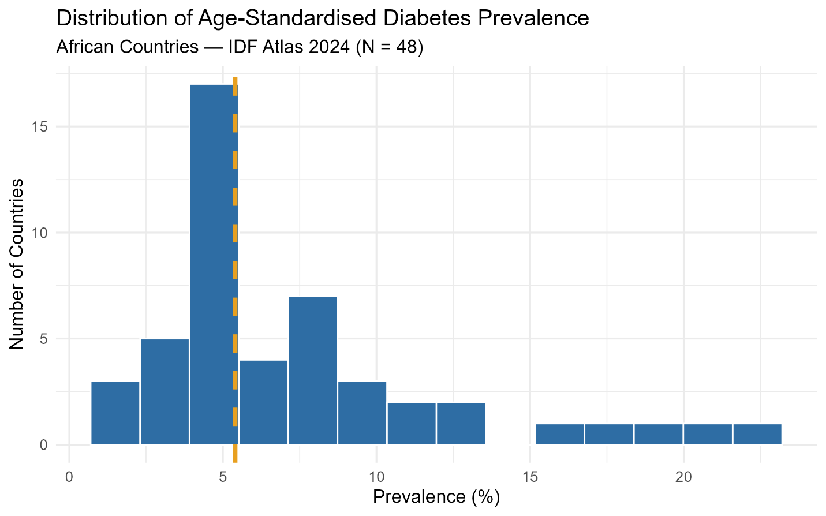
Figure 2. Distribution of Age-Standardised Diabetes Prevalence Across African Countries. The dashed vertical line represents the sample median prevalence of 5.40%, which was used as the threshold for classifying countries into low-prevalence and high-prevalence groups.

CART CLASSIFICATION OF HIGH-PREVALENCE AND LOW-PREVALENCE COUNTRIES
In order to answer Research Question 2, this part uses the CART model to determine which national-level diabetes variables best differentiate high-prevalence countries from low-prevalence nations.

CART MODEL PERFORMANCE
The CART decision tree model demonstrated strong predictive performance on the test dataset. The confusion matrix showed that the model correctly classified 13 out of 14 observations, yielding an overall accuracy of 92.86%. The model achieved a precision of 87.50%, a recall of 100%, and an F1-score of 93.33%. These results indicate that the CART model was highly effective in identifying high-prevalence countries and made only one classification error, where a low-prevalence country was incorrectly classified as high prevalence.
Figure 3. Pruned CART decision tree for classifying high and low diabetes prevalence
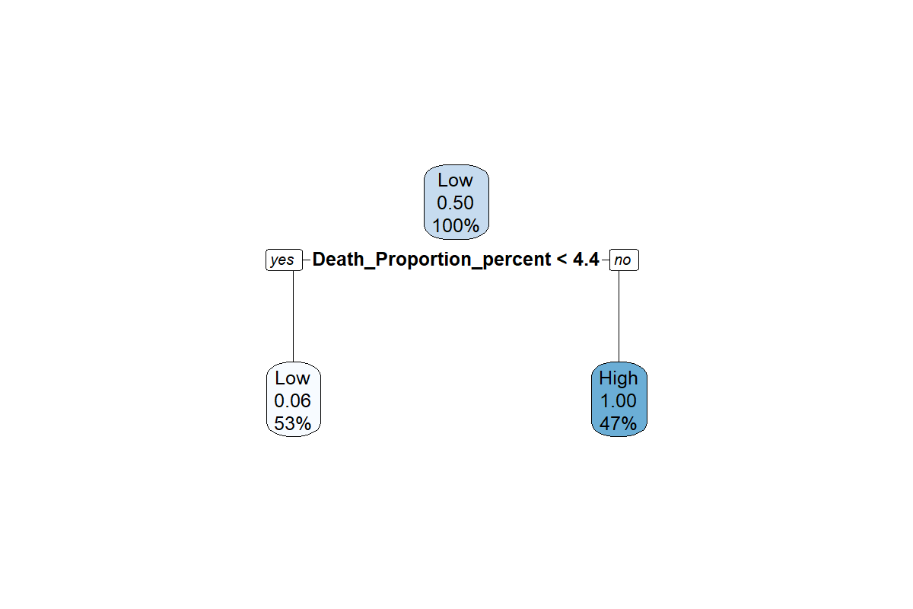
Figure 3. Pruned CART Decision Tree for Classifying High and Low Diabetes Prevalence. The final tree retained a single split based on the proportion of diabetes-related deaths in people aged 20–79 years, with a threshold of 4.35%.

INTERPRETATION OF THE PRUNED CART MODEL
The median age-standardised diabetes prevalence of 5.40% was used to classify countries into low-prevalence group and high-prevalence groups. In contrast, the pruned CART model identified a threshold of 4.35% for the proportion of diabetes-related deaths as the most effective split for predicting prevalence status. The pruned CART model retained a highly simplified and interpretable structure with a single terminal split based on the proportion of diabetes-related deaths in people aged 20–79 years. Countries with a diabetes-related death proportion below 4.35% were predominantly classified as low-prevalence countries, whereas countries with a value equal to or above 4.35% were classified as high-prevalence countries. This finding suggests that diabetes-related mortality burden is closely associated with broader national diabetes prevalence patterns across African countries.

VARIABLE IMPORTANCE
The variable importance analysis showed that the percentage of deaths attributable to diabetes was the most significant predictor in the CART model. This was followed by the percentage of adults with undiagnosed diabetes, the size of the adult population, the number of diabetes-related deaths, and the total amount spent on diabetes-related medical care. Although only the percentage of diabetes-related deaths appeared in the final pruned tree, the significance scores show that the other predictors contributed to the classification process prior to pruning. This implies that while the final decision rule was straightforward, the larger modelling process acknowledged the importance of several diabetes-related factors in differentiating nations according to prevalence status.
Table 3.Variable Importance in the Pruned CART Model
PREDICTOR | IMPORTANCE SCORE
Proportion of diabetes-related deaths (%) | 15.11
Proportion of people with undiagnosed diabetes (%) | 8.5
Total adult population aged 20–79 years (thousands) | 6.61
Deaths attributable to diabetes | 4.72
Total diabetes-related health expenditure (USD million) | 2.83
Note. Higher significance scores indicate stronger predictor contributions to the classification process. Although only the percentage of diabetes-related deaths appeared in the final pruned tree, the remaining predictors also contributed to the model before pruning.

COMPARISON OF CART AND LOGISTIC REGRESSION MODELS
This section addresses Research Question 3 by comparing the predictive performance of the CART decision tree model using logistic regression.

LOGISTIC REGRESSION PERFORMANCE
The logistic regression model achieved perfect classification performance on the test dataset. The confusion matrix indicated that all 14 test observations were correctly classified, resulting in an accuracy of 100.00%, a precision of 100.00%, a recall of 100.00%, and an F1-score of 100.00%. This suggests that the predictor variables were highly effective in separating high-prevalence from low-prevalence countries in the test sample. However, given the relatively small sample size and the limited number of test observations, this perfect performance should be interpreted with caution.

MODEL COMPARISON
A comparison of the two classification models showed that both performed well on the test dataset. However, logistic regression outperformed the CART model on all evaluation metrics. Although logistic regression achieved perfect classification on the test sample, CART remained highly competitive and offered the important advantage of interpretability through clear decision rules.
Table 4.Performance Comparison of CART and Logistic Regression Models
MODEL | ACCURACY | PRECISION | RECALL | F1-SCORE
CART | 92.86% | 87.50% | 100% | 93.33%
LOGISTIC REGRESSION | 100.00% | 100.00% | 100.00% | 100.00%
Note. Performance was evaluated using the test dataset. Although logistic regression achieved perfect classification on the test sample, this result should be interpreted cautiously given the relatively small sample size.

CHAPTER FIVE

DISCUSSION

DISTRIBUTION OF DIABETES PREVALENCE ACROSS AFRICAN COUNTRIES
The descriptive results demonstrated that the prevalence of diabetes differed significantly among the African nations included in the sample. With values ranging from 1.50% to 22.40%, the mean age-standardised diabetes prevalence was 7.38%, suggesting significant variation in the continent's diabetes burden. This wide variation implies that diabetes is not experienced uniformly across African nations and that national settings vary significantly in terms of disease patterns, detection, mortality, and health system response. The high mean proportion of undiagnosed diabetes (66.06%) also suggests that many cases may remain undetected, which may delay treatment and increase the risk of complications.
These descriptive findings support the broader epidemiological literature showing that diabetes prevalence and undiagnosed burden differ widely across countries, particularly in low-resource settings. Sun et al. (2022) and Ogurtsova et al. (2022) similarly documented substantial cross-country variation in diabetes prevalence and undiagnosed diabetes using harmonized international datasets. However, while those studies mainly provided descriptive estimates and projections, the present study extends the discussion by using these national-level indicators in a predictive classification framework. In this sense, the descriptive results not only confirm heterogeneity across African countries but also justify the use of classification techniques to distinguish countries by prevalence status.

CART CLASSIFICATION OF HIGH-PREVALENCE AND LOW-PREVALENCE COUNTRIES
The percentage of deaths from diabetes was found to be the most significant predictor in the CART model, which is a key finding of the study. According to the pruned decision tree, nations with a diabetes-related death proportion of less than 4.35% were primarily categorised as low-prevalence nations, whereas nations with values of 4.35% or higher were categorised as high-prevalence nations. This suggests that mortality-related metrics could be powerful indicators of more general problems with the diabetes system, such as poor disease management, delayed diagnosis, restricted access to treatment, and insufficient preventive care.
The results also demonstrated that the second most significant predictor in the CART model was the percentage of individuals with undiagnosed diabetes. This is significant because undiagnosed diabetes is a sign of weaknesses in early detection, awareness, and screening programs.Weak screening systems may cause many diabetes cases in African settings to remain undetected until complications develop, thereby increasing mortality and contributing to more severe prevalence patterns. Thus, the prominence of undiagnosed diabetes in the variable importance ranking highlights the importance of early detection and regular screening in public health.
The strong performance of the CART model also supports previous empirical studies showing that decision trees can provide practical and interpretable classification structures in health-related analysis. Ismail et al. (2022), Garcia-Rios et al. (2023), and Aglarci and Karakurt (2025) likewise highlighted the interpretability advantage of decision trees in diabetes-related prediction. However, unlike these earlier studies, which were mostly based on patient-level clinical datasets within single-country contexts, the present study shows that interpretable machine learning can also be meaningfully applied to country-level African surveillance data. In this regard, the study makes a methodological contribution by extending the use of decision trees from individual diagnosis to regional public health classification.
Another important finding from the CART results is the value of parsimony. Although the final pruned tree contained only one split, it still achieved strong predictive performance. This suggests that, in policy-oriented public health research, even a simple and transparent decision rule can be highly informative, especially in contexts where complex black-box models may be less useful for communication and planning.

COMPARISON OF CART AND LOGISTIC REGRESSION MODELS
The results show that both classification models performed well. CART achieved an accuracy of 92.86%, while logistic regression reached 100.00% on the test sample. This suggests that the country-level diabetes indicators used in the analysis carry strong discriminatory power, making it possible to clearly distinguish between high- and low-prevalence countries across Africa. In all the logistic regression outperformed CART on all evaluation measures, indicating that it captured the relationship between the selected predictors and diabetes prevalence status very effectively.
That said, the stronger predictive performance of logistic regression does not diminish the value of the CART model. Even though logistic regression delivered perfect classification on the test sample, this result should be treated with caution given the relatively small dataset, with only 14 observations in the test set. CART, on the other hand, offered something different: a simple and transparent decision rule based on the proportion of diabetes-related deaths. This kind of clarity can be especially useful for policymakers and health planners who need results that are easy to interpret and apply in practice.
In comparing the two approaches, a familiar trade-off becomes clear using predictive accuracy versus interpretability. Logistic regression provided the most accurate predictions in this case, but CART presented a more straightforward and policy-friendly way of classifying countries. In settings where clarity, communication, and practical decision-making matter most, CART may still be the more useful choice, even if another model performs slightly better in statistical terms.

STUDY IMPLICATIONS
The findings from this study carry clear practical implications for diabetes surveillance and policy planning across Africa. First, the strong influence of the proportion of diabetes-related deaths points to the need for closer monitoring of mortality indicators, as they may signal deeper weaknesses within health systems. In addition, the prominence of undiagnosed diabetes underscores the importance of strengthening screening systems, promoting early detection, and investing in public awareness campaigns. Without these efforts, a significant share of cases may continue to go unnoticed, thereby limiting effective intervention. Finally, the results demonstrate that interpretable machine learning approaches can be applied successfully to country-level surveillance data. This is particularly valuable in resource-constrained settings, where clear and accessible evidence can play a crucial role in guiding informed, data-driven policy decisions.

LIMITATIONS OF THE STUDY
Despite these contributions, a few limitations should be kept in mind. To start, the final analytical sample included only 48 countries, which is relatively small for predictive modeling and may limit how far the findings can be generalized.Another important point is that the analysis relied on cross-sectional data from a single reference year (2024). As a result, it does not capture how diabetes prevalence may change over time or reflect longer-term trends.In addition, the data are aggregated at the country level, so the results should not be interpreted as explaining individual-level diabetes risk. The patterns observed here apply to countries as a whole, not to individuals within them.Finally, the perfect performance achieved by the logistic regression model should be interpreted with caution. Given the small size of the test sample, this result may reflect the simplicity of that sample rather than consistent performance across different or future datasets.

CHAPTER SIX
CONCLUSION AND RECOMMENDATIONS

CONCLUSION
This study explored how interpretable machine learning can be used to classify African countries into high-diabetes prevalence group and low-diabetes-prevalence groups, drawing on national-level indicators from the IDF Atlas. The results show that both CART and logistic regression performed well, suggesting that these country-level surveillance indicators are capable of meaningfully distinguishing prevalence patterns across African countries. The CART model, in particular, highlighted the proportion of diabetes-related deaths as the most influential predictor and translated this into a clear decision rule using a 4.35% threshold. The logistic regression delivered slightly stronger predictive accuracy, CART brought a different kind of value like transparency, ease of interpretation, and straightforward communication, especially in policy contexts.Taken together, the findings suggest that interpretable machine learning approaches can serve as practical and policy-relevant tools for improving diabetes surveillance and supporting public health planning across Africa.

RECOMMENDATIONS
Based on the study’s findings, several practical recommendations were made:
First, African countries need to strengthen diabetes screening and early detection systems to reduce the high number of undiagnosed cases. Improving access to testing and encouraging routine check-ups would go a long way in identifying cases earlier.
Second, policymakers and public health planners should give more attention to diabetes-related mortality indicators. These measures can act as early warning signs, pointing to deeper gaps in prevention, diagnosis, and management systems.
Third, health ministries and relevant agencies would benefit from incorporating interpretable analytical tools such as decision tree models into their surveillance and planning processes. These tools make it easier to translate data into clear, actionable decision rules.
Fourth, future research should build on this work by using data across multiple years and including a broader set of country-level health system indicators. This would help determine whether the relationships identified here remain consistent over time.
Finally, there is value in extending this type of analysis beyond Africa. Comparing interpretable machine learning models across different regions could reveal whether these findings are unique to the African context or whether they apply more broadly.

References
Aglarci, A. V., & Karakurt, F. (2025). Symptoms affecting the development of diabetes: Analysis of risk factors with data mining. BMC Medical Informatics and Decision Making, 25(1), 319.
Almutairi, E. (2022). Statistical modelling and machine learning for the epidemiology of diabetes in Saudi Arabia [Doctoral dissertation, Brunel University London].
De Silva, K., Lee, W. K., Forbes, A., Demmer, R. T., Barton, C., & Enticott, J. (2020). Use and performance of machine learning models for type 2 diabetes prediction in community settings: A systematic review and meta-analysis. International Journal of Medical Informatics, 143, 104268.
Ganguly, R., & Singh, D. (2023). Explainable artificial intelligence (XAI) for the prediction of diabetes management: An ensemble approach. International Journal of Advanced Computer Science and Applications, 14(7), 158–163.
Garcia-Rios, V., Marres-Salhuana, M., Sierra-Liñan, F., & Cabanillas-Carbonell, M. (2023). Predictive machine learning applying cross industry standard process for data mining for the diagnosis of diabetes mellitus type 2. IAES International Journal of Artificial Intelligence, 12(4), 1713–1726.
Genitsaridi, I., Salpea, P., Salim, A., Sajjadi, S. F., Tomic, D., James, S., Thirunavukkarasu, S., Issaka, A., Chen, L., Basit, A., Luk, A. O. Y., Ma, R. C. W., Mbanya, J.-C., Ramachandran, A., Wild, S. H., Duncan, B. B., Boyko, E. J., & Magliano, D. J. (2026). 11th edition of the IDF Diabetes Atlas: Global, regional, and national diabetes prevalence estimates for 2024 and projections for 2050. The Lancet Diabetes & Endocrinology, 14(2), 149–156.
Ismail, L., Materwala, H., Tayefi, M., Ngo, P., & Karduck, A. P. (2022). Type 2 diabetes with artificial intelligence machine learning: Methods and evaluation. Archives of Computational Methods in Engineering, 29(1), 313–333.
Netayawijit, P., Chansanam, W., & Sorn-In, K. (2025). Interpretable machine learning framework for diabetes prediction: Integrating SMOTE balancing with SHAP explainability for clinical decision support. Healthcare, 13(20), 2588.
Ogurtsova, K., Guariguata, L., Barengo, N. C., Lopez-Doriga Ruiz, P., Sacre, J. W., Karuranga, S., Sun, H., Boyko, E. J., & Magliano, D. J. (2022). IDF diabetes Atlas: Global estimates of undiagnosed diabetes in adults for 2021. Diabetes Research and Clinical Practice, 183, 109118.
Poorani, K., Balakannan, S. P., & Karuppasamy, M. (2025). Mitigating data imbalance for robust diabetes diagnosis using machine learning and explainable artificial intelligence. Journal of Current Science and Technology, 15(3), 111.
Sun, H., Saeedi, P., Karuranga, S., Pinkepank, M., Ogurtsova, K., Duncan, B. B., Stein, C., Basit, A., Chan, J. C. N., Mbanya, J.-C., Pavkov, M. E., Ramachandaran, A., Wild, S. H., James, S., Herman, W. H., Zhang, P., Bommer, C., Kuo, S., Boyko, E. J., & Magliano, D. J. (2022). IDF Diabetes Atlas: Global, regional and country-level diabetes prevalence estimates for 2021 and projections for 2045. Diabetes Research and Clinical Practice, 183, 109119.

